“8 best vibe coding tools for 2025: build smarter, faster apps
- Sharon Hafuta
- 2 days ago
- 13 min read

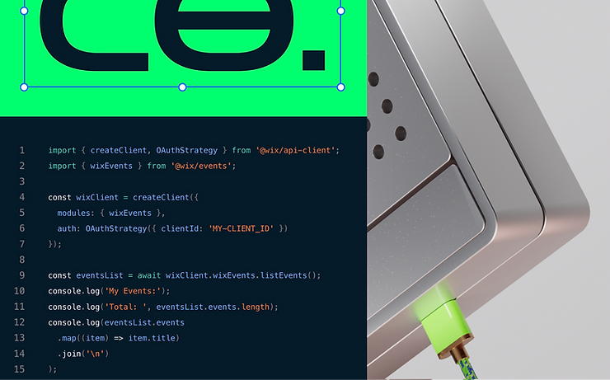

Imagine building an entire app without writing a single line of code, just by describing your idea in plain English. That’s the power of today’s vibe coding tools. In this guide, we’re sharing the best vibe coding tools of 2025, introducing platforms that will help you turn ideas into working products faster, with less technical friction.

And it’s catching on fast. According to Stack Overflow, 84% of developers say they use or plan to use AI tools in 2025, up from 76% the year before. More people are turning to vibe coding to build faster, experiment more and bring their ideas to life with fewer blockers.
That’s where vibe coding tools come in.

These platforms let you describe what you want without complex syntax or full-stack know-how required and turn it into working code. From Base44 to tools like Cursor, Bolt and Lovable, we’re seeing a new wave of platforms that make building feel more like prompting.

Let's explore the best vibe coding tools available today: what makes each one unique, who they’re best for and how to use them while staying in control of your app’s logic, flow and performance.

One to watch: Base44 lets you build full-stack apps just by describing what you want. If you want to see vibe coding in action, start here.

TL;DR: best vibe coding tools

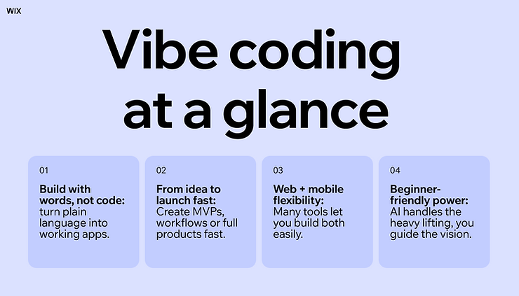

Vibe coding lets you build websites, apps and even internal tools using simple, natural language prompts instead of traditional code. It’s a game-changer for creators who want to move fast, test ideas or launch products, without needing full-stack development experience.

Keep reading to learn what makes each tool unique, how to use them and why vibe coding is quickly becoming the go-to approach for anyone learning how to make a website or an app using AI.

- Vibe coding is a new approach to app and site creation that uses AI and large language models (LLMs) to translate plain English into code.

- It’s perfect for building minimum viable products (MVPs), AI workflows, internal tools or even full-featured products.

- Top platforms like Base44 combine AI logic with intuitive UIs, making them great choices for beginners and pros alike.

- While these tools are powerful, you’ll still want to understand the basics of API use, security and project scope before going live.

- If you’re debating between building a website vs mobile app, vibe coding tools often let you do both, with little extra effort.

- One of the biggest benefits of creating a mobile app this way is how quickly you can go from idea to launch without hiring a full team.

"Vibe coding makes us all creators and app builders. As a non-technical founder, v0.dev from Vercel has been my favorite tool of 2025. The reason? For the first time in my life, I can take an idea and build a prototype that's ready to hand over to our dev team for production." - Brett Farmiloe, founder and CEO at Featured.com

How we chose the best vibe coding tools

Criteria | Things to consider
Ease of use | Can non-developers or solo creators build without friction?
AI transparency | Does the tool let users see, edit or understand the code being generated?
Platform versatility | Can you create web apps, mobile apps, or both?
Security & API management | Does it support secure API integration and user authentication?
Integration with builders | Can you combine it with a website builder, app builder or CMS easily?
Real-world use cases | Are people actually using it to launch products or grow businesses?

These criteria helped us narrow down a fast-evolving space to the platforms that offer the most flexibility, trust and creative control, especially for users who are figuring out vibe coding in 2025.

8 best vibe coding tools

Whether you're building a side project, prototyping for a startup or creating full-scale digital products, vibe coding tools offer a flexible middle ground between low-code no-code ease and full-code control. They’re designed to feel lightweight and intuitive, yet powerful enough to support creative, complex ideas.

"Vibe coding changes app building because it removes so much of the friction between idea and execution. Instead of getting stuck in endless setup and syntax, you can focus on creating features and refining the user experience in real time." - Georgi Petrov, CMO at AIG Marketer

Let’s explore nine standout platforms that blend design, app development and AI in different ways. Some lean into visual simplicity, others give you the raw power of code with AI-enhanced flow, but all of them share one goal: helping you build in your own style.

Here are the best vibe coding tools worth exploring:

- Base44
- Cursor
- Bolt
- Lovable
- v0
- Supernova
- Glide
- Rosebud AI

01. Base44

Base44 is an AI app builder that lets anyone turn ideas into working apps in minutes. Using just natural language, you can create personal tools, back-office apps, customer portals or complete enterprise products that are ready to use.

This no-code vibe coding tool lets you describe your app’s functionality in plain English and automatically builds it, complete with a fully set-up backend, so non-technical users don’t have to configure or manage anything manually.

What Base44 offers:

- AI-generated code with real-time feedback.
- Built-in database and authentication features.
- Instant deployment and version control.
- Collaborative team workflows.

Who it’s built for: Base44 is the right choice if you want an end-to-end app with a built-in backend, live hosting and zero manual setup. It’s designed for creators who don’t want to worry about infrastructure or writing code, but still want to launch something real. Whether you’re testing a product idea, building a workflow or creating a client-facing tool, Base44 helps make it happen without the typical technical overhead.

Base44 pricing (shown as annual rates; monthly plans available too):

- Free plan: Access all of Base44’s core features at no cost and see what it can do.
- Starter ($16/mo): Build out your first apps for personal projects or early-stage ideas.
- Builder ($40/mo): Take your idea to the next level with tools to meet your professional goals.
- Pro ($80/mo): Access advanced tools and support for developing complex applications.
- Elite ($160/mo): Scale your app effortlessly with top credits and dedicated support.
- Enterprise (contact sales for pricing): Unlock custom plans, a dedicated architect and account support to meet your organization’s unique needs.

Ready to turn your ideas into reality? Sign up for Base44 and start building your app today.

02. Cursor

Cursor is an AI-enhanced code editor that runs inside a customized version of VS Code. It’s built to help you write, understand and refactor code using natural language prompts.

What Cursor offers:

- AI code generation and explanation.
- Instant codebase search.
- Smart autocomplete and error catching.
- Native GitHub integration.

Who it's built for: Cursor is ideal for developers working on production-level software, especially those juggling large or legacy codebases. It’s also great for solo devs and indie makers looking to move faster.

Rather than replacing coding, Cursor augments your workflow. It’s like pairing with an expert dev who helps you unblock, document or debug in real time, all without leaving your editor. And if you're exploring the benefits of creating a mobile app, Cursor makes it easier to prototype, test and iterate across platforms using tools you're already familiar with.

Cursor pricing (shown as annual rates; monthly plans available too):

- Hobby (free plan): Two-week trial, limited agent requests and tab completions.
- Pro ($16/mo): Extended limits on agent, unlimited tab completions, access to background agents, bugbot and maximum context windows.
- Ultra ($200/mo): 20x usage on all OpenAI, Claude, Gemini models, priority access to new features.

03. Bolt

Bolt is a lightweight app builder that lets you create and test ideas through conversational prompts. Think of it as a mix of prototyping tool and AI-powered sandbox.

What Bolt offers:

- AI prompt-based interface for app logic and design.
- Real-time previews.
- Component reuse and auto-layouts.
- Collaborative editing.

Who it's built for: Bolt is perfect for startup teams, designers and makers who want to quickly sketch out MVPs or pitch-ready concepts with working interactions.

Bolt minimizes friction. You can start with a vague idea and turn it into a functional prototype in minutes. It’s great for validating ideas before investing in full dev.

Bolt pricing (shown as annual rates; monthly plans available too):

- Free plan: Public and private projects, 1M tokens per month, 150K tokens daily limit, file upload limited to 10MB.
- Pro ($18/mo): Public and private projects, start at 10M tokens per month, increased file upload limit to 100MB, no daily token limit, unused tokens roll over to next month.
- Teams ($27/mo): Everything in Pro, plus centralized billing, team-level access management, granular admin controls and user provisioning, private NPM registries support and design system knowledge with per-package prompts.
- Enterprise (custom pricing): Get advanced security, compliance and 24/7 support—customized to your team’s exact needs.

04. Lovable

Lovable is a visual builder with a strong focus on beautiful, usable UX. It prioritizes simplicity, helping users design clean interfaces and logic flows with minimal clicks.

What Lovable offers:

- Drag-and-drop editor.
- UX-focused component library.
- Pre-built logic blocks.
- Real-time preview and publishing.

Who it's built for: Lovable is ideal for product designers, non-tech founders and creators who care deeply about visual polish but don’t want to touch code.

What makes Lovable stand out is its curated, opinionated approach. It doesn’t try to be everything, it just does visual app building really well.

Lovable pricing (shown as annual rates; monthly plans available too):

- Free plan: Discover what Lovable can do for you.
- Pro ($21/mo): Designed for fast-moving teams building together in real time.
- Business ($42/mo): Advanced controls and power features for growing departments.
- Enterprise (flexible billing): Built for large organizations needing flexibility, scale and governance.

05. v0

v0 is an AI UI generator by Vercel that lets you describe UIs in natural language and generates production-ready React components.

What v0 offers:

- Chat-based UI generation.
- Fully editable React/Next.js code.
- Code export with Tailwind and shadcn/ui.
- Integrates with Vercel deployments.

Who it's built for: v0 is a sweet spot for frontend developers, UI engineers and designers who want a fast way to jumpstart code while keeping full control.

Unlike many AI builders, v0 doesn’t lock you in. You get real code you can tweak, ship and scale with, no hidden layers.

v0 pricing (shown as monthly rates):

- Free: For people looking to explore.
- Premium ($20/mo): For higher limits and power users.
- Team ($30/user/mo): For fast moving teams and collaboration.
- Enterprise (custom pricing): For large companies that require additional security.

06. Supernova

Supernova is a design-to-code platform that converts design systems into code-ready components, making it easier to maintain design consistency in production.

What Supernova offers:

- Figma sync and design tokens.
- Code generation for multiple frameworks.
- Versioning and component management.
- Cross-platform support (React, Flutter, etc.).

Who it's built for: Supernova is built for design systems teams, frontend devs and product orgs that want to keep code and design in sync.

Supernova reduces the overhead of translating design into production. With support for real frameworks and full customization, it’s an ideal bridge between design and dev.

Supernova pricing (shown as annual rates; monthly plans available too):

- Free: Starter features for individuals.
- Team ($35/editor/mo): Design system collaboration
- Company ($80/editor/mo): Mid-tier subscription tailored for organizations looking to scale their design systems and documentation workflows.
- Enterprise (custom pricing): For advanced security and support.

07. Glide

Glide is a no-code app builder that turns Google Sheets or Excel files into sleek, functional web apps with logic, permissions and design flexibility.

What Glide offers:

- Data-driven app creation.
- Drag-and-drop editor.
- User authentication and role-based access.
- Mobile and desktop responsive designs.

Who it's built for: Glide is best for internal tool builders, operations teams and non-technical founders who want working apps without developers.

Glide lowers the barrier to entry for app building. If you can use a spreadsheet, you can ship a functional app in a day.

Glide pricing (shown as annual rates; monthly plans available too):

- Free: Limited features, Glide branding.
- Explorer ($19/mo): Explore the core features of Glide.
- Maker ($49/mo): Launch your apps to the world.

08. Rosebud AI

Rosebud AI is a next-generation vibe coding platform that transforms plain-language app ideas into fully functional web applications, with visuals, assets and deployment built in. Its assistant “Rosie” acts like a junior developer-designer hybrid, generating code and creative assets on demand.

What Rosebud AI offers:

- Prompt-driven app generation, by simply describing your app, Rosebud generates full React/HTML/CSS code live in the editor.
- Instantly generate icons, illustrations or even 3D models using AI, no external tools required.
- All code is visible and editable in real-time, giving you full control over structure and styling.
- Publish your app instantly to a hosted URL, auto-updated with each revision.
- Versioning and remixable projects.

Who it’s built for: Rosebud AI targets creative makers, educators, side-project builders and indie developers who want to build both logic and visuals quickly, especially when art and interface matter.

Rosebud AI is uniquely compelling because it doesn’t separate code from design, it unifies them. You can prototype UI, app logic and visuals in one workspace, and deploy instantly. This reduces friction and gives creative makers a real edge in moving fast and staying creative.

Pricing (based on annual billing, with monthly options available):

- Free plan: Basic AI generations, community remix access, limited deploys.
- Contact Rosebud directly to explore all pricing plans.

Summary of the best vibe coding tools
Platform | What it is | Best for | Key features | Pricing
Base44 | AI-powered app builder for generating full-stack web apps from prompts. | Creators who want an end-to-end solution with a built in backend. | Prompt-to-live product, reusable components, visual database editor, AI debugging. | Free plan available. Paid plans from $16/month billed annually.
Cursor | Code editor with built-in AI that helps developers write and refactor code. | Engineers looking for faster workflows inside their IDE. | Built-in AI pair programmer, code search, native GitHub integration. | Free plan available. Pro starts at $16/month.
Bolt | Visual backend builder with AI assistance and structured logic flows. | Developers and startups building scalable app infrastructure. | AI-powered logic builder, integrated database, modular workflows. | Free plan available. Pro starts at $18/month.
Lovable | Design-to-code platform that turns Figma into deployable React apps. | Designers and devs working in React who use Figma as a source of truth. | Pixel-perfect Figma-to-React conversion, GitHub export, logic and routing. | Free for 1 project. Paid plans start at $21/month.
v0 | AI UI builder by Vercel that turns prompts into Tailwind components. | Front-end developers and teams working in the Vercel ecosystem. | Prompt-to-UI generation, React + Tailwind code output, component library. | Free during beta. Paid plans start at $20/month.
Supernova | Design system workspace that syncs design tokens and documentation. | Teams managing large design systems across tools and platforms. | Design token sync, Figma integration, documentation hub, developer handoff. | Free for 1 project. Paid plans start at $35/month.
Glide | No-code app builder that lets you create full apps from spreadsheets. | Businesses and creators building internal tools or MVPs. | Spreadsheet-to-app UI, logic builder, user roles, integrations. | Free plan available. Paid plans start at $19/month.
Rosebud AI | Platform for building character-driven games and story experiences. | Creators building AI-driven narratives, agents or NPCs. | AI agents, visual editor, deployable scenes, asset generation. | Free beta access. Paid plans TBD.

"Vibe coding includes design, security and functionality as one fluid process. You are building intelligent from the start instead of fixing problems later on. For the beginners, start small, concentrate on getting the core experience right and let vibe coding lead you to best practices along the way. Think of it as having guardrails so that you can move fast without worrying about crashing." - Spencergarret Fernandez

Editor’s note: all pricing and information are current as of 08/13/2025.

How to choose the right vibe coding tool for you

With so many innovative platforms on the market, choosing the right vibe coding tool comes down to understanding your creative process, your technical comfort level and the type of product you want to build. Whether you're prototyping an app, building a website or launching a business, your ideal tool should feel like an extension of how you think.

Here’s how to break it down:

Are you a designer-first thinker?

If you're coming from Figma or Sketch, look for tools with native design handoff, responsive layout systems and clean code output. Platforms like Supernova and v0 are made to preserve visual intent while giving you dev-level control.

Are you building with AI?

If you're interested in prompting instead of coding, lean into tools like Base44 or Cursor which bring AI directly into the build flow. These let you iterate on components, logic or design by asking, not writing.

Do you want code, no-code, or low-code?

- Go no-code if you want to build advanced apps quickly, while the platform handles all the complexity for you.
- Choose low-code (e.g. Base44) if you want to define your app’s logic in natural language while getting built-in support for structure and setup.
- Go full-code + AI assist if you're a developer looking to accelerate your workflow without giving up control.

What are you actually building?

Different tools shine for different use cases:
- Internal tools & dashboards → Base44, Glide.
- Client projects & sites → Base44, Supernova.
- Product ideas or MVPs → Base44, Bolt, v0, Rosebud AI.
- Developer-first builds → Base44, Cursor.

Some tools generate clean React or Next.js code you can export. Others keep you locked in. If long-term flexibility matters, check the fine print before you commit.

Criteria | Ideal tools | Why these stand out
AI-driven builders | Base44, Cursor, Rosebud AI | Prompt instead of code, AI-assisted logic, design and dev workflows.
No-code simplicity | Base44, Glide, Bolt | Rapid building, minimal setup, intuitive visual interfaces.
Low-code flexibility | Base44 | Add logic without heavy lifting, structured yet customizable.
Full-code + AI acceleration | Cursor | Full control with AI pairing, ideal for dev-heavy workflows.
Use case: internal tools | Base44, Glide | Great for teams, internal dashboards and quick iterations.
Use case: client sites/projects | Base44, Supernova | Visual control + client-friendly delivery.
Use case: MVPs/product ideas | Base44, Bolt, v0, Rosebud AI | Fast prototyping, launchable results, flexible architecture.
Use case: Dev-heavy builds | Base44, Cursor | Code-forward environments with optional AI assist.

What’s next for vibe coding tools?

Vibe coding is still in its early stages, but it's evolving fast. As more builders lean into natural language inputs, real-time collaboration and AI-native experiences, we’re seeing a shift from traditional code editors to platforms that feel more like creative studios. This movement isn't just about simplifying development, it's about reimagining who gets to build and how ideas come to life on the web.

Expect future vibe coding platforms to:

- Blur the lines between design and code.
- Offer deeper AI integrations for logic, layout and UX.
- Support even more complex applications without writing manual code.
- Open new doors for teams, from solo creators to enterprise dev squads”

